New U.S. Embassy in London to Showcase 007-Level Security and Style
March 4, 2014 12:50 PM
Having outgrown its home in the Eero Saarinen-designed London Chancery Building, the Embassy of the United States in London is getting a new home. Nancy Lazarus sizes up the project, a transparent, crystalline cube now taking shape on London’s South Bank.

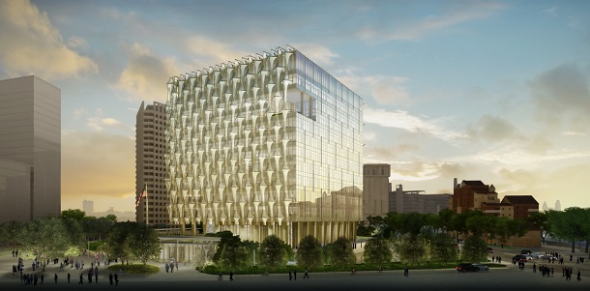
(Renderings courtesy of KieranTimberlake/Studio amd.)

“The U.S. government is taking their design seriously again,” said David Sprouls, president of the New York School of Interior Design. His proof? Under the State Department’s Excellence in Diplomatic Facilities program, the American government is commissioning noted architects and designers to build embassies and consulates worldwide. He spoke briefly at NYSID’s “Design Diplomacy” event last week, where plans for the new London embassy were previewed.

Currently 31 international projects are in the design or construction phase, and these facilities have evolved beyond the purpose-built or modern compounds of earlier U.S. embassies, according to Jerry Withers, project manager at the State Department’s Bureau of Overseas Buildings Operations that manages the program. They’re part of the 2010 Embassy Design and Security Act, whose flexible design standards encourages more local influences and cultures.
“Showcasing and representing America well abroad while still being functional, sustainable and safe”: those are the tall tasks of the embassy design program, Withers said. One of the toughest design challenges is to convey U.S. openness since security requirements have tightened in the wake of overseas incidents.
The new U.S. embassy in London is the most high-profile project, and it began about six years ago, when Kieran Timberlake was awarded the architectural design after an international competition. November 2013 marked the groundbreaking and the opening is slated for 2017.
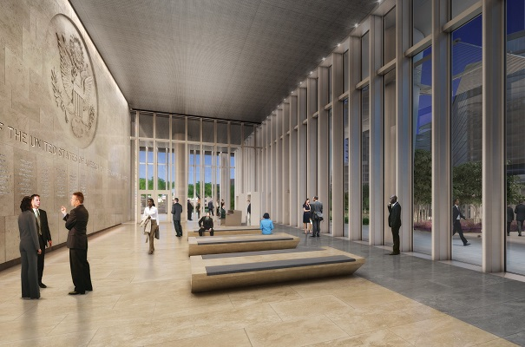
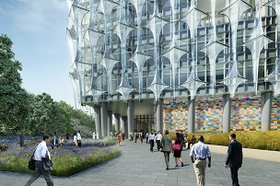Richard Maimon, principal at Kieran Timberlake gave a virtual tour of the London embassy compound, including pavilions and gardens. He said it’s been complicated since 48 different agencies are involved. Among the myriad objectives are sustainability and presenting “at least the appearance of visitation and openness.”
The embassy is situated in London’s Nine Elms area south of the River Thames in a largely industrial section. The new location is closer to Parliament than the current U.S. embassy in Grovesnor Square. “The embassy will be the centerpiece of the 4.5 acre-site,” Maimon said. “The overall design theme is a spiral that continues upward, though there are local height restrictions. The finished scheme has several entrances.”
The landscape and grounds set the tone, and Maimon said they took a layered approach, leaving the impression of transparency. There’s a “promenade across the pond and woodlands that offer protected views.” Sustainability goals were stringent, and his firm worked to transform the standards to maximize the glass, he explained. The result is space with mostly natural lighting.
The interior and work areas are also airy and visually open, with flexible and movable work stations, noted Chris Banks, principal at Gensler, the firm consulting on workplace design. But with lower dividing walls the space is also less private, so they’re using soundproofing materials and techniques. To enhance the work ambience, every floor will have a common area, with coffee bars and gardens.
The British public and London embassy personnel will have to wait a few years for the project’s completion. In the meantime, the process will keep being environmentally friendly, sustainable, secure yet welcoming, and carry on.
Writer Nancy Lazarus is a frequent contributor to UnBeige.

